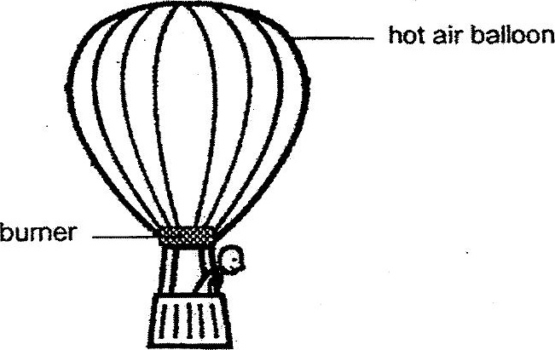

When the bumer was switched on, it heated up the air inside the balloon. The  
hot air fills the balloon, causing it to rise.

(a) If the hot air balloon is already in the air, what could Alan do if he would dike  
the balloon to go higher up in the air? (1m) .

Study the electrical system shown below. When the switch is closed, the  
nichrome wire, which is connected to the wires in the.circuit, becomes hot  
and soon, the piece of paper moved. .

