41. Saily is going for a picnic. She packed the same type and amount of food.in  
two different containers which are of the same size. The containers are made  
of different materials and the covers remained closed once the food was put

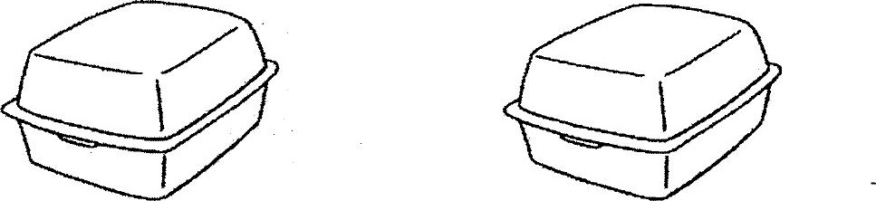

After one hour, Sally checked on the food and observed the results as  
shown in the table below.



(2) Based on the above information, state a possible reason why the food in  
container A is still warm but not container B. (4m)

(>) Fishmongers keep fish fresh by storing them in containers filled with ice.  
Based on the data from the table only, which container, A or B, is made of a  
material which is less suitable for making the container to keep fish fresh?  
Explain your answer. (2m)

(c) Sally observed that the surface of container A became wet. However, the .  
surface of container B remained dry: What can be concluded about the  
material used to make container A? (1m)

