

LEVEL : PRIMARY 6  
SCHOOL : : RED SWASTIKA

SUBJECT : : SCTENCE /  
TERM +. PRELIMINARY EXAMINATION

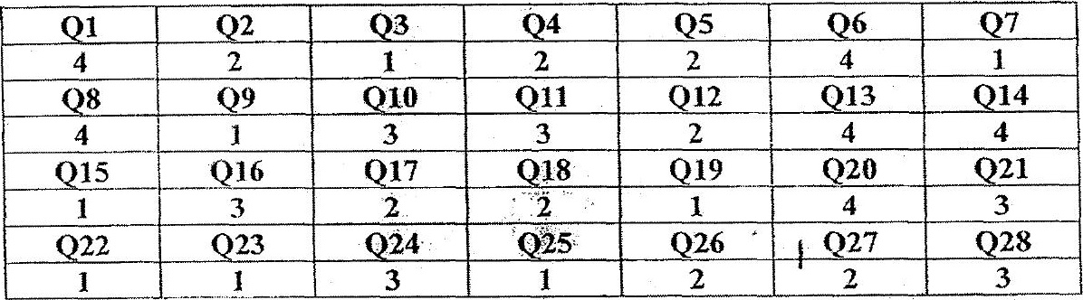

O29 (a) Decomposer



(929 (c) The simpler substances broken down by the decomposers acts as  
fertilisers.





Q30 (c) A contro] set-up allows her to compare and confirm that any  
difference in the duration the flewers remain fresh is dué to the  
: use of ‘simply fresh’? which is the only variable.

