

(ii) | Water vapour is given out by the plants through the opening.  
When the water vapour comes inte contact with the cooler  
inner surface of the plastic bag, it loses heat and condenses to  
form water droplets on the plastic bag.

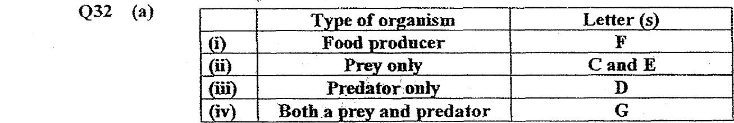

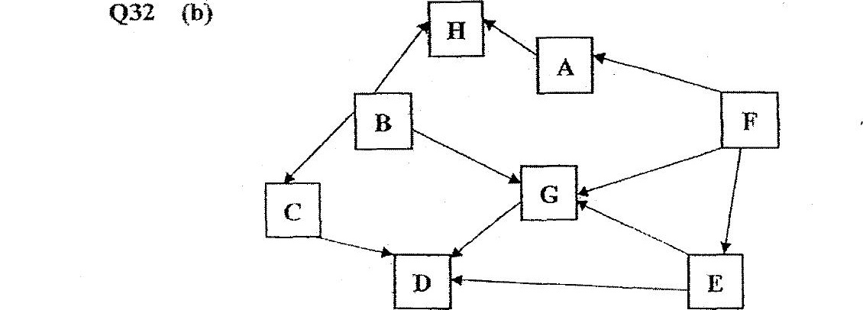

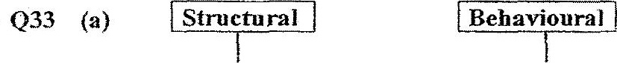

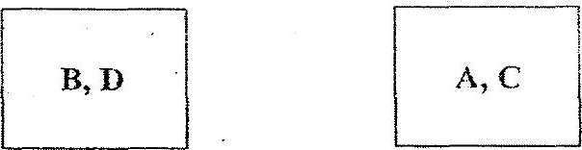

(i) Ube so reduces the amount of sunlight entermg the waiter.  
As a resuit, the plants photosynthesize less and produced less