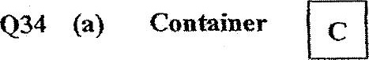

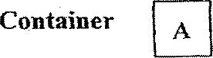

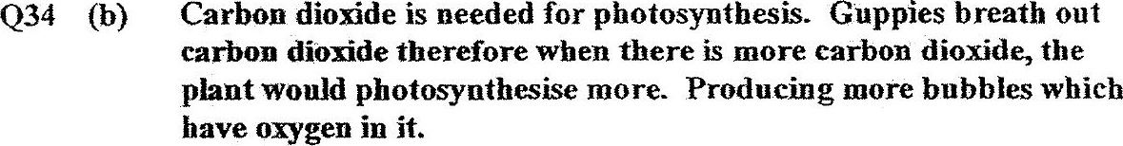

035 (a) Sharp ince & straight hair.

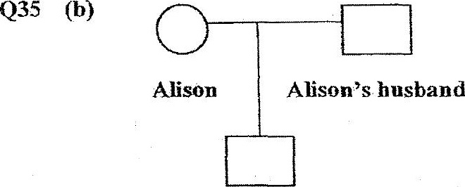



036 (a) More water was collected im container X as the amount of water  
yapours that lest heat and condensed on plate A is more. This  
shows that plate A is a better conductor of heat than plate B.

Q36 (b) Only liquid can evaporate, solid like the biue dye powder can't  
therefore when liquid Q gained heat from the buasen burner and  
evaporated it was colourless as the powder could not evaporate with  
the liquid.

Q37 =Andy could on the heater’s temperature below substance B’s melting point  
so when substance B melts finish, Andy could pour it away. Andy could  
then put the empty container on standby so when substance A finish  
  
. melting, it could pour it into the empty container.