2. The picture below shows some vegetables and weeds growing together in  
a vegetable farm.

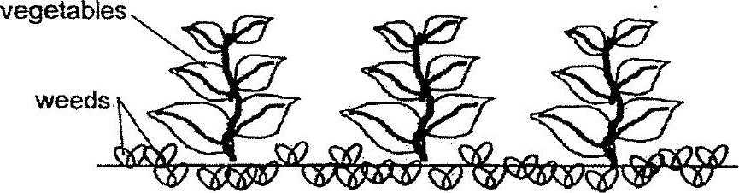



C: space-  
D: — suntight  
F- nutrients

(4) Cand D only  
  
(2) 8B, C, and E only  
(3) A,B, Dand E only  
(45 A, B.C, DandE