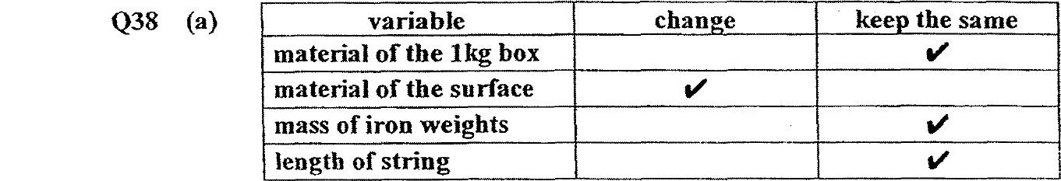

Q38 (b) Surface Q. The distance moved by the box ts the least. here is the  
most friction between the box and the surface and can prevent the  
user from slipping.

O39 (a) Series

Q39 (b) When the circuit is closed, the iron rod became magnetised and  
attracts the steel plate which is a magnetic materia}. This results in  
the striker hitting the bell.

O39 (c) Property 1: Object X isa non-agnetic material.  
Property 2: Object Xisa coiiductor of electricity.

O40 (a) Alan could make the fire burn bigger.

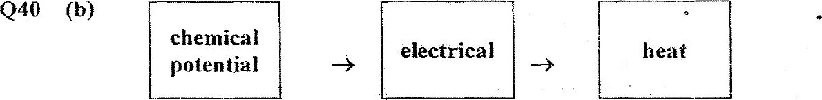

O40 (c) Whenthe nichrome wireis:heated, the air surrounding the wire Is  
heated. Air expands when Keated and pushes the paper as the air  
takes up more space.

Q40 (d) Yes. There will be less electrical energy to heat the nichrome wire.  
The surrounding air will expand less, reducing the speed of the

Q41 (a) Container’A is made out of a poor conductor of heat and container  
Bis made out of a good conductor of heat.

Q41 (b) Container B. It allows more heat to flow from the surrounding air  
to the container. The ice gains heat and melts more quickly. This  
will not keep the fish fresh.

O41 (c) The material is not waterproof.