3. Sam pasted four dry green Dean seeds on a styrofoam board. The styrofoam  
board was then lowered into a container filled with cooled boiled water  
covered with a jayer of oil as shown in the diagram below.

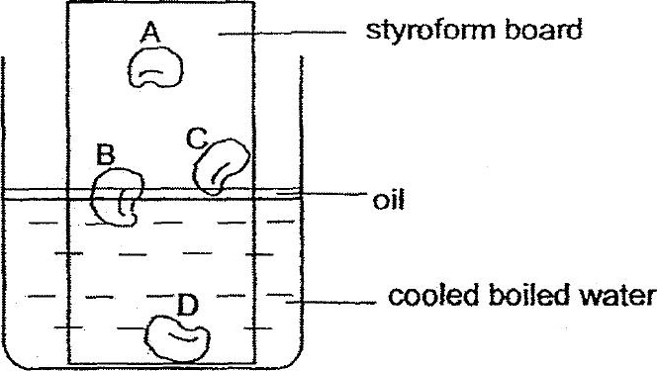

(1) B only  
  
(2) AandC only  
(3) Band C only  
(4) Band D only

4. The table below compares the sexual reproduction between humans and  
flowering plants.

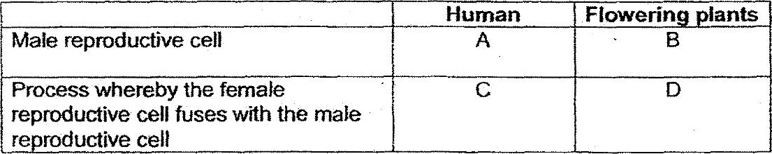

Which one of the following correctly identines A, B, C and D’?

