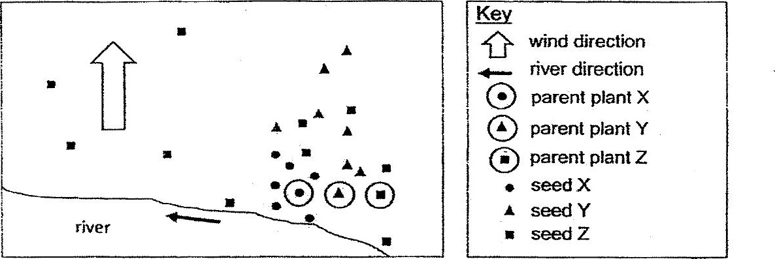

Which of the following correcily shows the fruils of plants X, Y and 2  
respectively?

