6. The same amount of blood sample was taken from four different blood  
vessels in the body. The graph.below shows the comparison of the amount  
of oxygen in the blood sample.

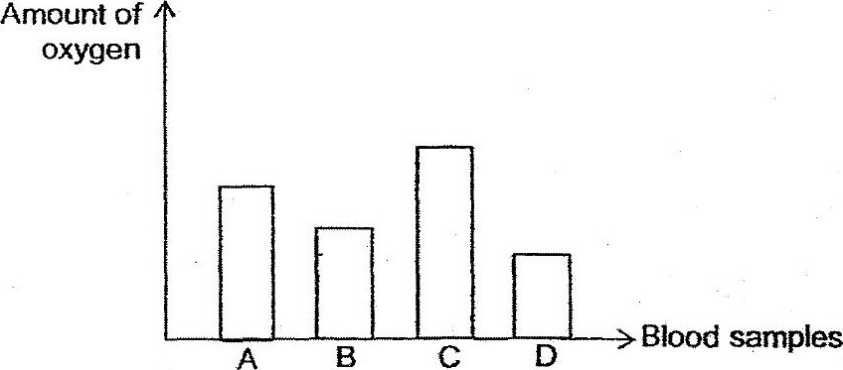

Which of the following correctly shows where the blood sample was taken  
from?

