7. The diagram below shows the parts of plant A.

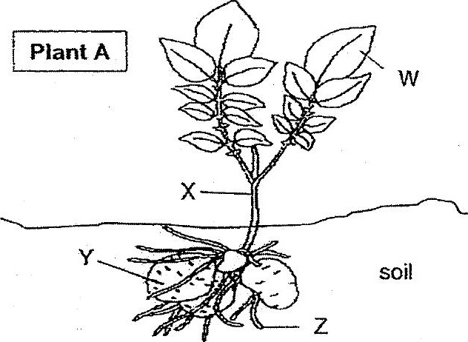



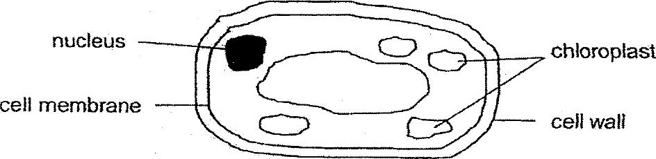



(1; W  
  
(2) xX  
  
(3) ¥  
(4) 7