11. -Study the food web below.

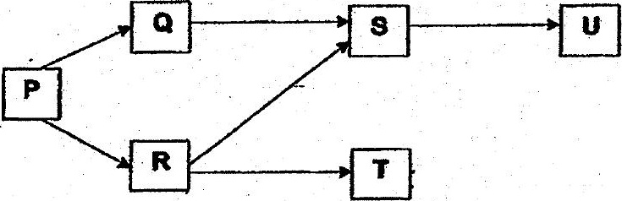

Organism X, which only feeds on U, was introduced into the habitat.

..-Which of the following graphs. shows how the. populations of R and U are most  
likely to be affected?

(<) Number of



