12. The diagram shows plant M which.can only. grow on tree Dranches. Bird P feeds  
on the fruits of plant M which have sticky seeds. When bird P files away, it rubs  
its beak with the.sticky seeds against the branch of another free. ,  
ye TGs Ey: es -  
: oy es EEE a awe ie  
eas RO a re plant M with leaves and fruits  
‘ NOTRE rene "I P  
Yas  
pecan  
on . . C

(1) Fruit of piant M are dispersed by wind  
  
(2) Plant M grows on tree branches so that it can avoid birds  
  
(3) Plant M gets its food and water from the branches of the tree;  
  
(4) Bird P helps to disperse the seeds of plant M from one tree to another tree.

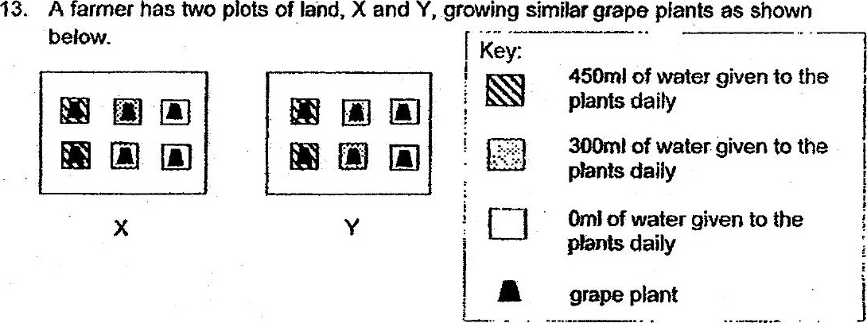

Which of the following is/are the possibie-aim(s) of his experiment when he  
planted the grape plants on the two plots of land?

A ‘To find out if water is needed for the plant growth.  
B To find out how the amount of water helps in plant growth.  
C To find out if the soi in- plot X has more nutrients than the soil in plot Y.

(1) B only (2) Band C only  
(3) AandC only (4yA, Bandc