14. Rui En fied three identical containers with. an equal amount.of water taken from  
a river, All the containers were placed in a well-lit room filled with different number  
of similar type of fish and water plants.

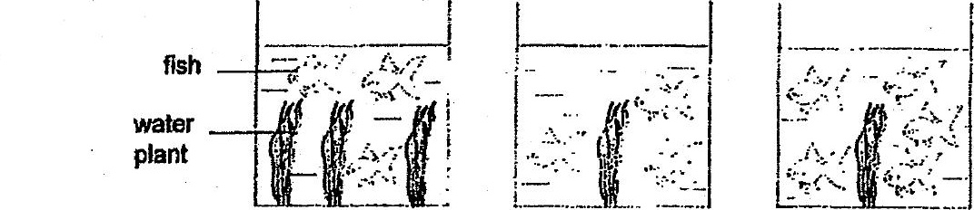

The water in all the containers have the same amount of oxygen at the start of  
the experiment. After 5 hours, she recorded the amount of dissolved oxygen in  
the water in container Y.

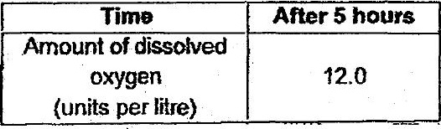

_ Which of the following would be the correct amount of dissolved oxygen in the  
water in containers X and 7 after.5 hours?

