15. A solid metal cuba oF SU cm? was put into a measuring cylinder containing  
450 cm? of water. The water level rose as shown. :

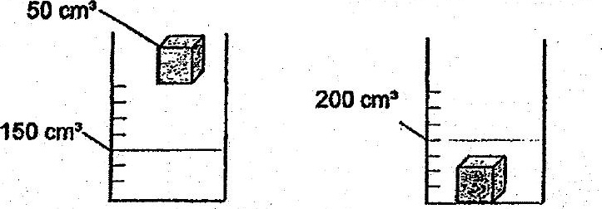



What can we conciude from the above experiment?

(1) A solid has a definite volume and a definite shape.  
(2) Asolid has a-definite volume but no definite shape.  
  
(3) A solid has no definite volume and no definite shape.  
(4). Asolid has no definite volume but has a definite shape.

16. Which of the following sequires:only a:pulling-force?

{1) inflating a balloon - (2) knocking on a coor

ee KE  
| WE,

ng nay  
j  
en os Le.  
eet. Bae AL La eae  
= Beare ss ASS  
A eae