17, ‘he diagram below shows a pendulum swinging from position A to position B  
to position C and then back to position B.

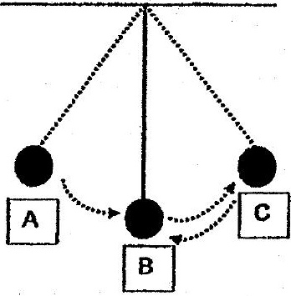

_ Which of the following shows the change in the amount of potential energy and  
kinetic energy in the pendulum? : .

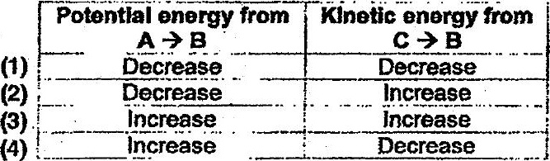

13. Peter wants to make a swimming board.

Kea 7  
Gir Se a ie.. swimming board  
SAS ANS Seepsat oo". tes  
ae ae een  
Toa gern Sears  
IE ie, ERS .  
. RET i

Which of the following is themost important property of the material to make the  
swimming board?

(1) strong  
  
(2) flexible  
  
(3) transparent  
  
(4) cannot sink in water