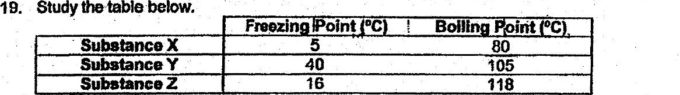

Which of the following is irue7

Ql) Xand Z are solids at 10°C.  
  
: 2) Yand Z are liquids at 20°C.  
(3) Y and Z are liquids at 80°C.  
{4) Xand Y are gases at 100°C.

20. Substance X. was heated for a period of time. The graph below shows the  
temperature change of substance X over time during the heating process.



