21. Two identical bulbs, Buib A.and-Bulb 6, are.connected.in.a circuit as shown.  
below. Both buibs light up with equal brightness when the switch is closed.

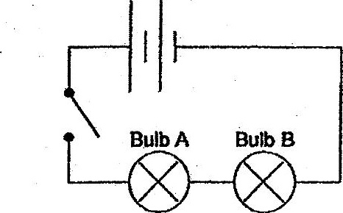

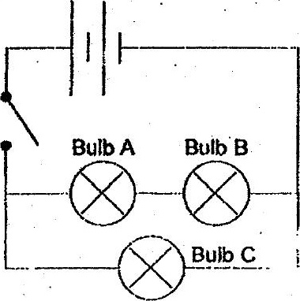



(4) Bulb C does not light up.  
  
(2) Bulb C is as bright as Bulb A.  
(3) Bulb Cis dimmer than Bulb B.  
(4). Bulb C is brighter than Bulb A.