22. Fhe circuit dlagram shows two batteries connected -to four bulbs. When one of  
the bulbs fuses, tho other-three bulbs still remain lit. Which bulb is this? .

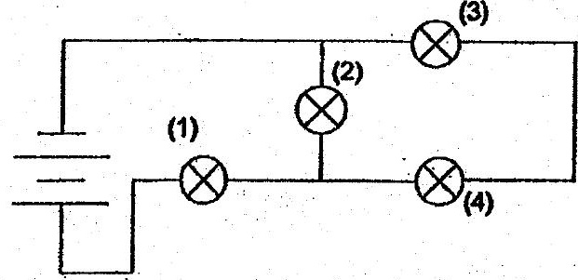

north pole of  
‘small magnet

Andy brought 2 magnets near each other. He observed their movements as  
shown below.

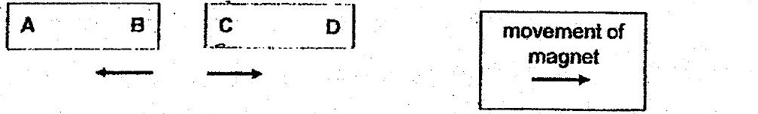



He placed a compass at B and observed the position of its needle which is as  
shown below.

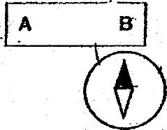

VVhich of the Tollowing are possibie poles of A and C?

