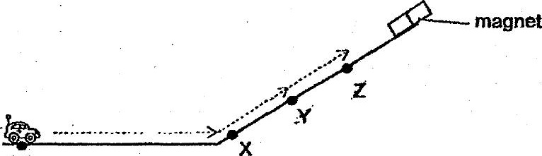

‘When the toy car was releaséd at point Y, it would roll down the slope. When  
the toy car was released at point Z, it continued to move up the slope. Which  
ara-ttie forces-acting on the-toy:carat points. and 2:

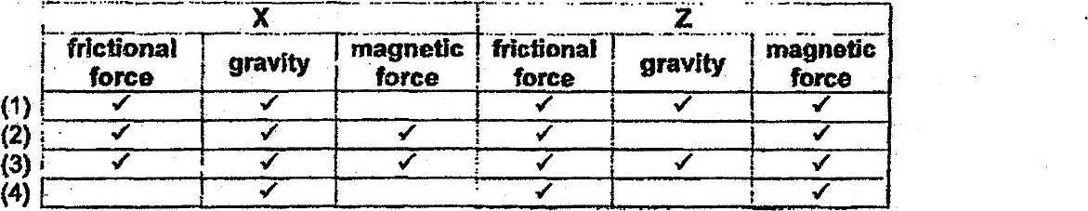

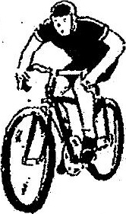

Which of the following exptains why his speed increases as he moves down the  
slope?

(1) His weight increases.  
  
(2) More gravity Is pulling the man and the bicycle. .  
  
{3) - There is less frictional force between the bicycle and the slope.  
  
44) The man and the bicycle are moving in the same direction as gravity.