26. Three conductors of heat, A, Band C, have been arranged according to how well  
they conduct heat as shown below.





Good conductor Poor conductor  
of heat of heat

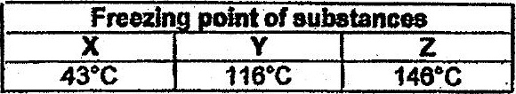

A nail with subsiances 4, Y or 2 was giued onto conductors A, B or C at equal  
distance from the flame as shown below. Which nail will be the first to drop?

