For questions 23 to 41, write your answers in this booklet. The number of marks  
available is shown in brackets | } at the end of each question or pari question.

29. Simon carried out.an experiment fo study the.effect of some environmental factors  
on dead leaves. He placed the dead leaves.and some damp soil in a container as  
shown below.

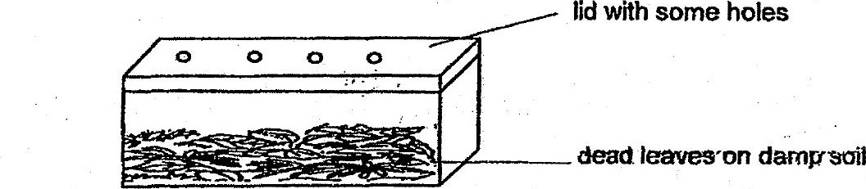

After a few weeks, the dead leaves turned into a damp black substance which  
could be used as fertiliser.

(a) Name the process that caused the dead leaves to turn into a damp black  
substance. {t]

(6) Without changing any of the apparatus used nor adding water, suggest two.  
methods how Simon could make the dead leaves turn into the black substance  
faster. _ plain your answer. 7 33



