30, Ahmad prepared.a set-up to find.out whether germinating seeds. produce carbon  
dioxide. He soaked five seeds in water before placing them in the flask. He Jeft  
the set-up in a warm and dark place for two days.

Aiter two days, he observed tnat some of the seeds in the set-up germinated and  
a the limewater.turned milky. Limewater turns milky in the presence of carbon. :  
“dioxide. . it 7

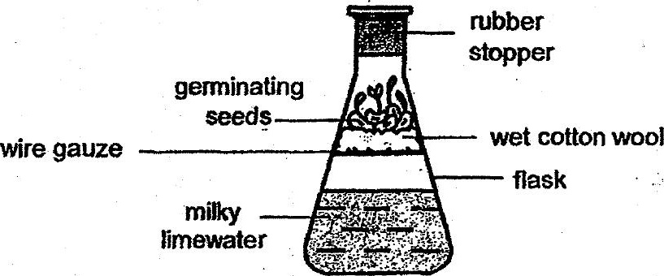

(a) Explain why the limewater turned milky.

(b) Some of the seeds did not germinate. What will hapnen to these seeds after a  
week? Explain your answer. . [2]

