position P and the food-carrying tubes from the stem at position Q.

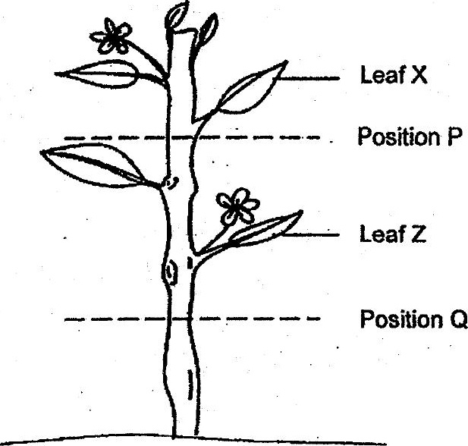

(a) After some time, Emily observed that Leaf X had withered but not Leaf Z.  
Give an explanation for her observation.

(b) At the same time, Emily also observed a swelling in the stem above the cut  
at position Q. Affer a week, the plant died. Explain why this happened.  
uo {1]

