graph below.  
: Ali starts dancing

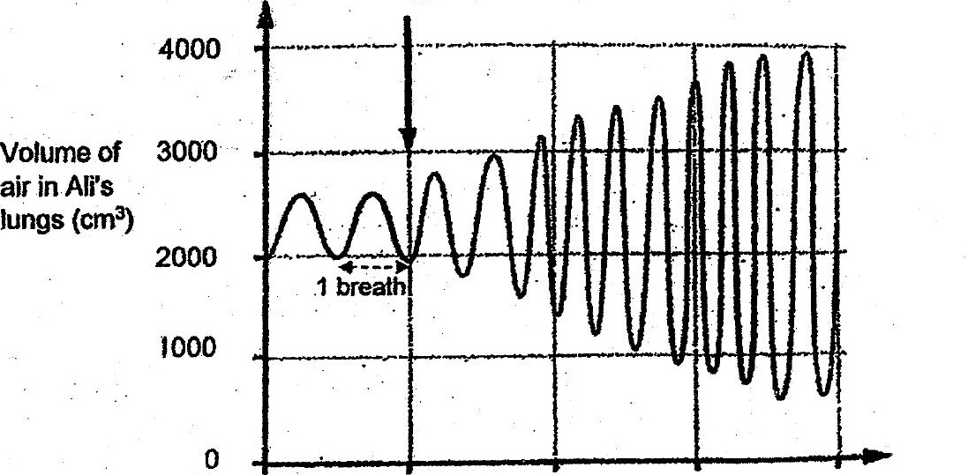

0.5 1.  
8 Time (min)



Gi} Alls breathing rate

