33.. Leaves have tiny openings called stomata on their surfaces.

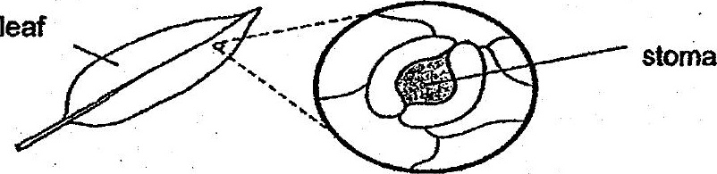

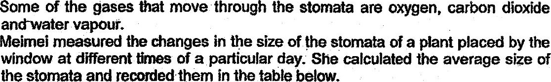

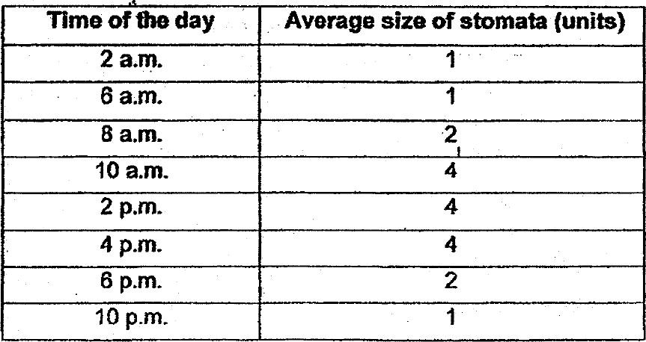

(a) Based on the table above, ihe plant photosynthesises the most from 10 a.m.  
to 4 p.m. Explain why. t’

(6) Explain how the change in the size of the stomata in the presence of light can  
be a disadvantage to a plant growing in a desert, fi}

(c) What do you think Meimei did in the experiment to ensure that her resllts  
were reliable? .

