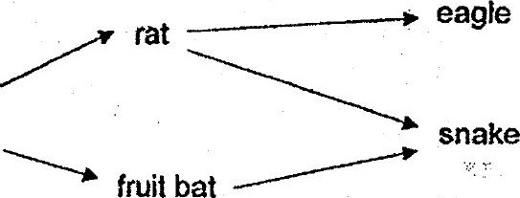



(a) A large number of snakes were killed Dy some hunters. Expiain how this  
. activity affected the population of the food producer. “

(b) A huge forest fire broke out on the island. Two. consumers were able to escape  
to another island. Which are the two consumers and give a reason for your

