35. Jack conducted an-expenment using two similar types of plants for pots G and H,  
with different sizes of leaves. The two pots of plants with the same amount of soil  
were placed in a garden and watered with the same amount of water at the start  
of the experiment. A transparent glass cone was placed over each plant where  
water would be collected al the base as shown.

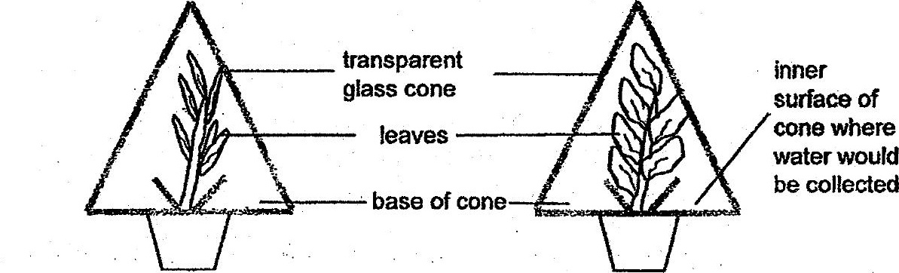

After one day, Jack measured the volume of water collected and recorded the  
results as shown below”

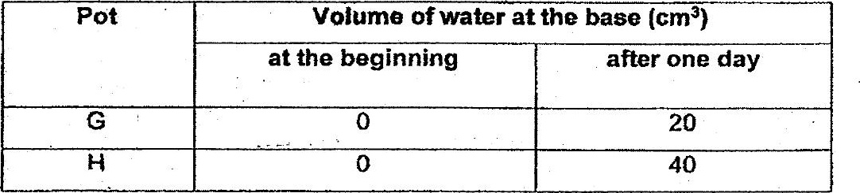

(a) Which pot, G or H, collected more water? Explain why more water was  
collected at Hts base of the cone.

