The diagram below shows two types of leaves found growing on different trees, X  
and Y. During winter, the water stays frozen as snow on the ground and very little  
water reaches the roots of the trees. ,

$1  
We  
% Oy Z  
eR ee  
AE “  
ee Be  
NES  
Se hy  
RN eyes ,  
ae A  
TREN  
ARN WS :  
RS” :





(b) Which tree, X or Y, will not need to shed its ieaves during winter? : .  
Explain your answer. ; iy

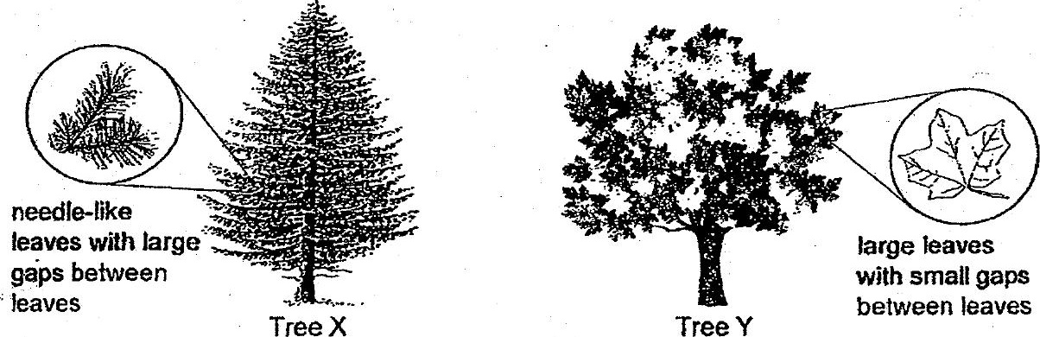

(c) Strong winds can causé tree ‘pranches to break. Branches of which tree,  
X or Y, would more likely break when there js a strong wind? Explain why.

