36. The joliowing set-up represents ihe water cycle.

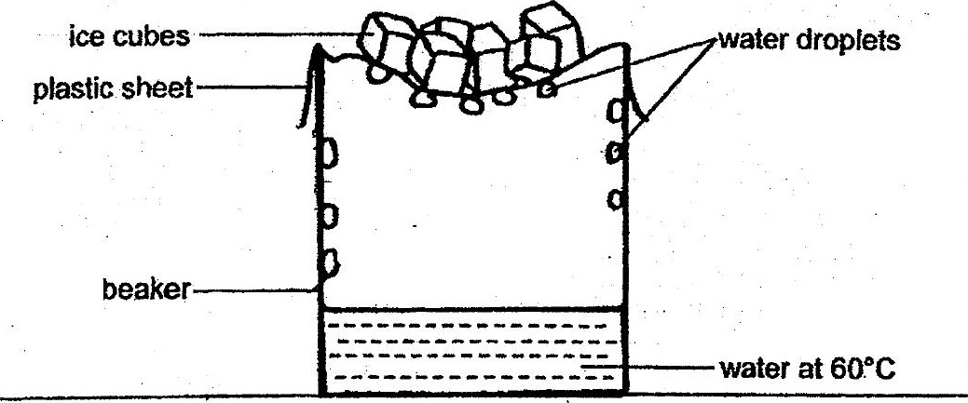

(a) Explain how the water droplets are formed on the underside of the plastic  
sheet. {2}

(bo) What would happen to the rate at which the water droplets are formed if the  
temperature of the water placed in the beaker was increased to 95°C?  
Explain your answer. 12]

