37. .Ahmad set up the following circuit.

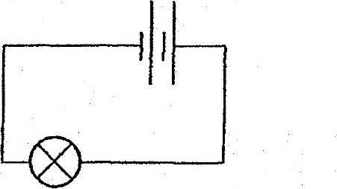

He measured the brightness of the bulb with a light sensor. He then added  
  
another battery and measured the brightness of the bulb. He repeated the  
  
. experiment for different number of batteries and recorded his measurements  
: - -- In the table below. a

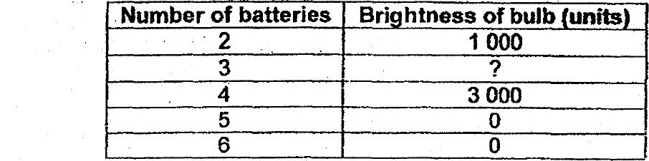

(a) What is a possible measurement tor the brightness of the bulb when three  
batteries were used? {11

(b} Based on the resulis, when the number of batteries used is four or below  
what is the relationship between the brightness of the bulb and the number of  
batteries? 4}

(c) Give a reason why the brighiness. of the bulb Is zero when five batteries were  
used. : £47

