38. Matihew had 2 set-ups, A and B, to find out how the type of surface affects  
- the distance moved by an object on'the surface. He applied equal force on  
each of the blocks and measured the distance. travelled by them.

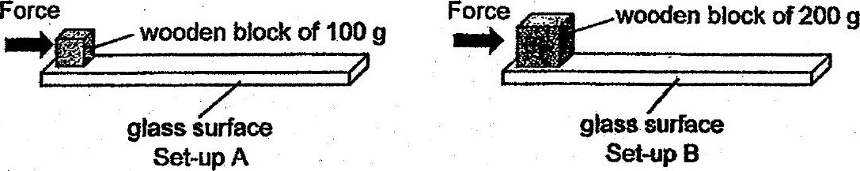

(a) Matthew's teacher said that his set-ups were incorrect. Desenbe two changes  
- that- Matthew shoutd make fo Set-up.B so that he can test his aim correctly.

(b) Besides friction and the force exeried by Matthew, which other force is  
present in this experiment? {17

