39. The diagram below. shows two similar sized iron cubes. released from point X.  
There was a loud thud when the cubes landed on-the cement floor.

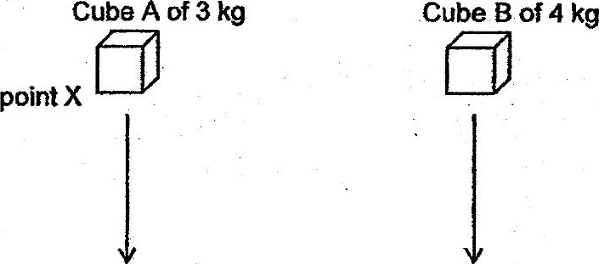

cement floor

(a) State the energy conversion when Cube A was released from the height and  
landed on the cement floor. : y

