40. The following set-up is installed along a corridor to count the number of  
students walking along the corridor into a classroom. :

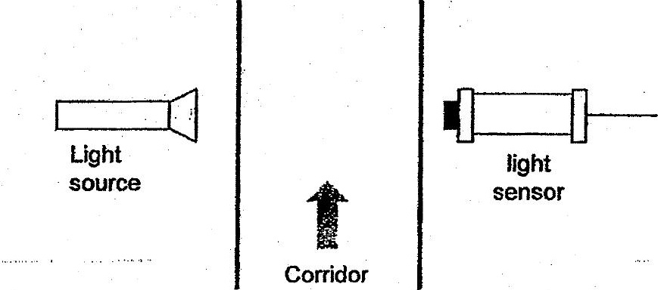

The following table shows the light sensor readings when the set-up 's  
working.

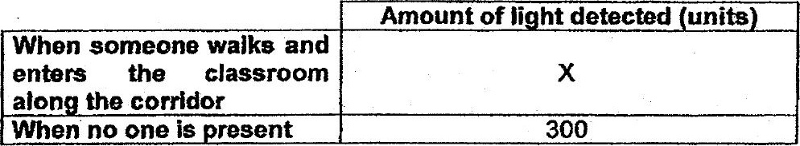





(6) Explain how the above set-up is able to detect the number of peopie waiking  
past the corridor. . . [2]

