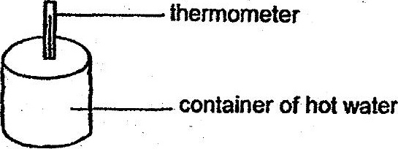

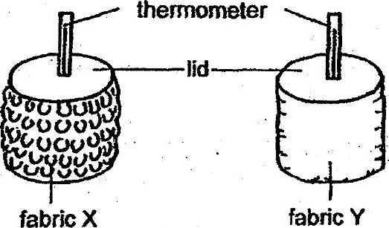

She recorded the temperature of the water at regular intervals in the table as  
shown below.

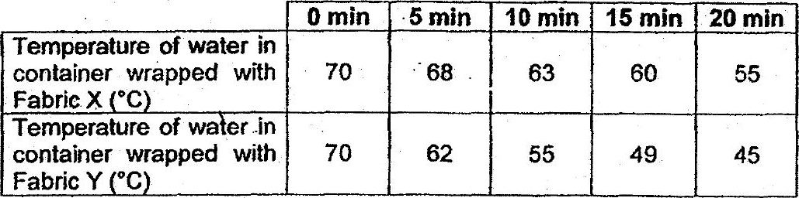

(a) How. does the temperature of the water in the container wrapped. with  
Fabric X change as the time increases? (7

(b) Which fabric should’ Meiling use to make a shirt to keep a person cooler in a  
warm surrounding? Explain your choice. {2)

