Carbon dioxide is a greenhouse gas. An increase in the amount of carbon  
dioxide in. the Earth's atmosphere.resulis in.global warming. Study. the three  
graphs shown below on the change in the average temperature of the Earth  
over a period of time.

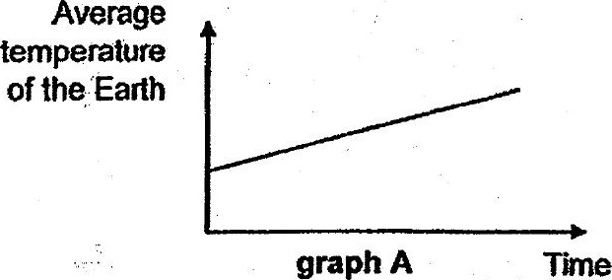

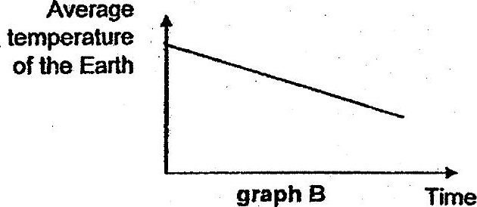

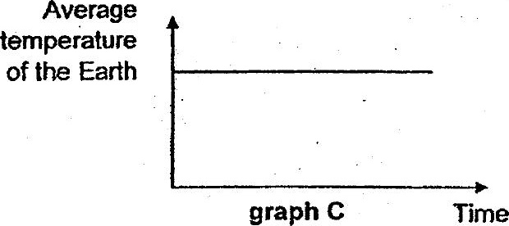

(c} Which graph, A, B or C, shows the correct change in the average temperature  
of the Earth if the amount of carbon dioxide increases over time? Explain your  
answer. {1}



