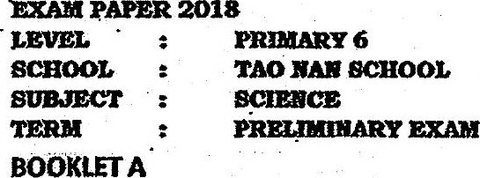

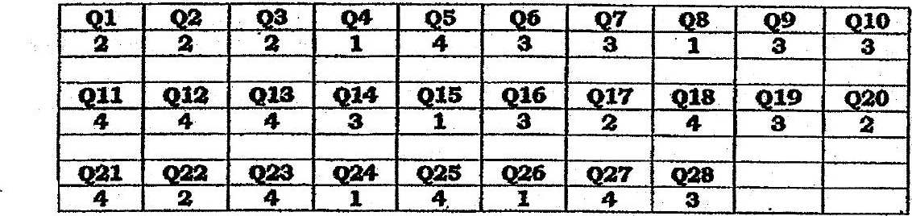

Q29. {a} Decomposition.  
th} Method 4: Place the apparatus in a warmer place.



Q35. {a} When. the seeds germinated, they produced casbon dioxide which came into contact with the  
. limewoater and caused it to turn milky.

(b} The seeds would de and decompose. The presence of warmth, water and air allowed the bacteria  
in the flask to decompose the dead seeds.

Q31. fa} Water can be transported from the roots-to teaf Z but not Leaf X, thus Leaf X could not  
photosynthesise and hence it withered. .

{b) There Is swelting as the food produced by the plant during photosynthesis cannot be transported  
to the reots, causing them to die. Therefore, the roots can no longer absorb water and the plant died.

Q32. {a} @) The volume of alr taken in Increases.

{i} His breathing rate increases. . :  
(b) All takes in oxygen through his mouth-and nose, which enters his lungs where It Is absorbed by the  
air sacs. The heast then pumps the oxygen-rich blood to hls lees.

033, {a} ‘The average size of the stomata Is the biggest hence the most carbon dioxide istaken in. |  
fb) When there is a huge amount of light, the size of the stomata of the desert plant Increases,  
resulting in an increase In the amount of water loss,

{c) She measured the size of at least 3 stomata for each timing.

Q34. {a} Decreases, There are fewer snakes to feed on rats and fruit bats. Hence thelr population Increases -  
and they feed n more plants.  
fb} The eagle and fmit bat. Both of them have wings that allow them to fly and escape to another  
island, while the rat and sake are unable to fly. .