

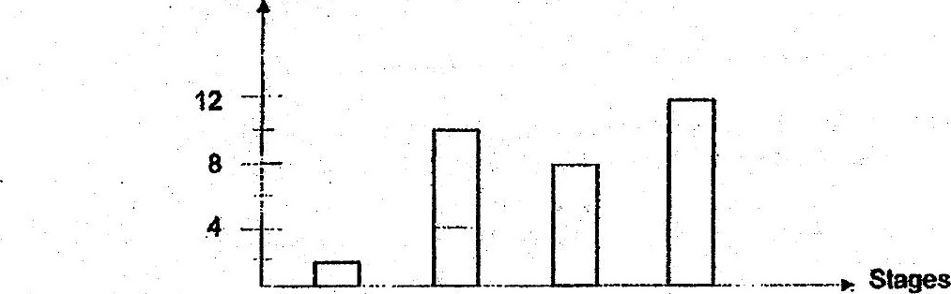



Male reproductive cells are-produced in the male reproductive parts.

B The tertiised egg. develops in the ovary.

Fertiisation occurs in the ovary.

Which of the following is correct?

