4. Haoming sete up an experiment as shown below ‘te-find out. if the- absence. of  
reols affects the amount of water. abserbed.

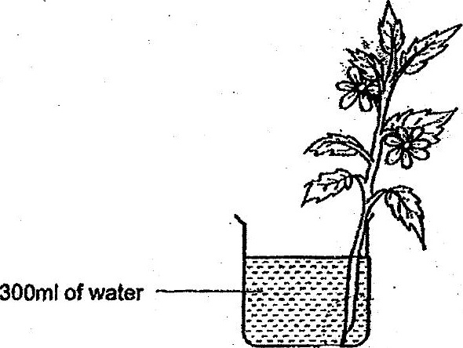

Which. of the following should Haoming use as the control set-up for his  
experiment?

