5. The diagram below shows .the-movement of blood in pathways, A, B, C and. D,-of  
the human circulatory-system:

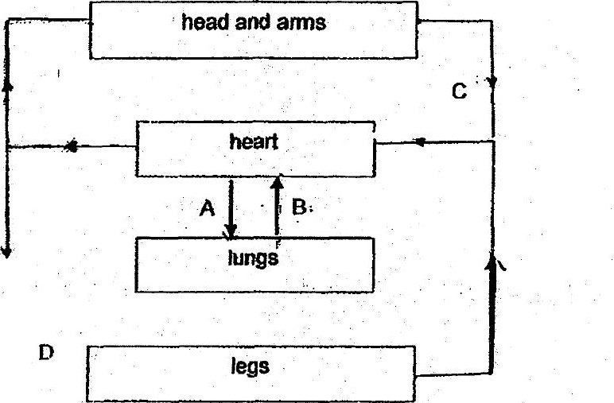

Which of the following correctly shows the pathways where biood Is rich in oxygen  
or carbon dioxide?

