6, Cells X shown below has been.taken from 4 plant.

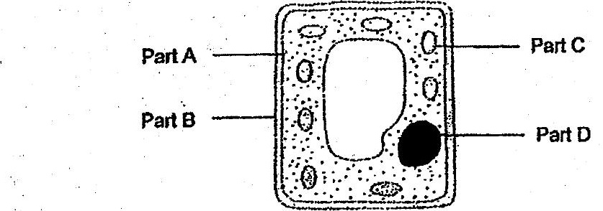

Which of the following is true about cell X?

(1) Part A gives ceil X its regular shape.  
  
(2).Part‘C contains genetic information for cell X.  
  
(3) Pait D controls all the activities that take place in cell X.  
(4).Part 8 controls the substances entering and leaving cell X.

> brown fur os  
Fos, a i Han __ brown winter coat  
Xe oan \ Ligh ~~ made using fur  
Vim ' ee | ‘MLS, from Animal Q  
yoo se eat 1 iD.  
" woe Ne  
AnimalQ- ~

(1) The fur helps the wearer to blend in with.white wails.  
  
-(2) The fur is dark coloured so it gains Jess, heat from the sun.  
  
(3) The fur traps air so the wearer will lose fess heat fo the surroundings -  
(4) The fur helps the wearer gain more heat from the cold air to keep warm.