8. The mep below shows the location of some animal farms.along a river. The animal  
waste from the farms flowed into the river.

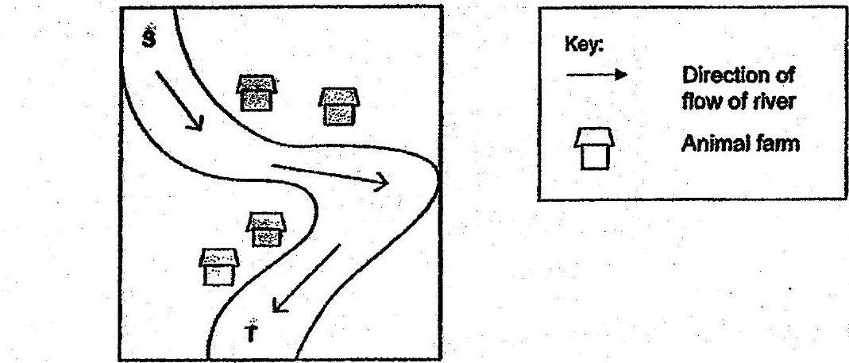

(1) fish  
  
(2) bacteria  
  
(3) nutrients —  
(4) carbon dioxide

9. The amount of different gases tn the air is shown in the pie chart below,  
¥

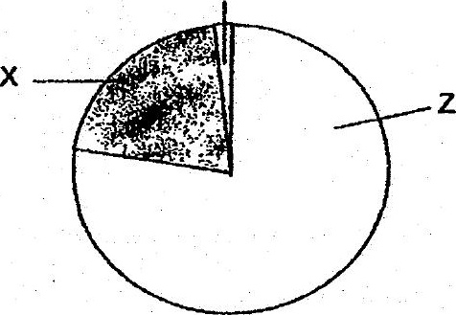

Which of the following statements is true?

(+). Plants take in only Z'when there ts light.  
  
(2) Plants produce-Z:during photosynthesis.  
  
(3) There Is less X in exhaled air than in Inhaled air.  
(4) There is. more ¥ in.inhaled ais than in exhaled air