10. . Five samples of food were.taken from the following five parts, A, B, C, D and E,  
of the human digestive system.

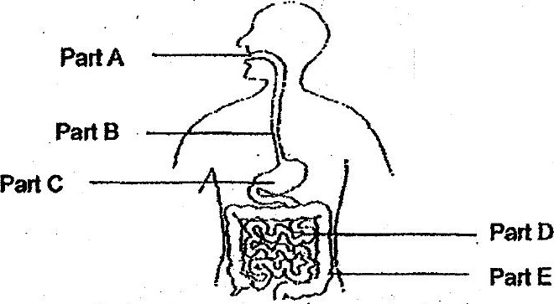

the amount of undigested food at the five parts was plotted in the graph shown  
below.

Which line in the graph beiow represents the amount of undigested food in the  
five parts, A, B, C, D and E?

