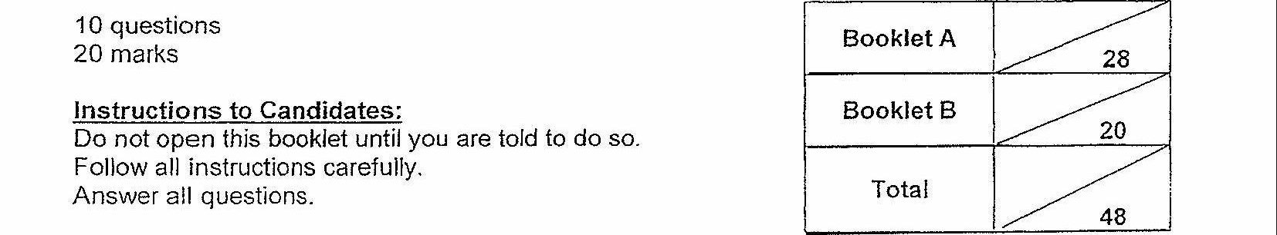



This booklet consists of 5 printea pages.