

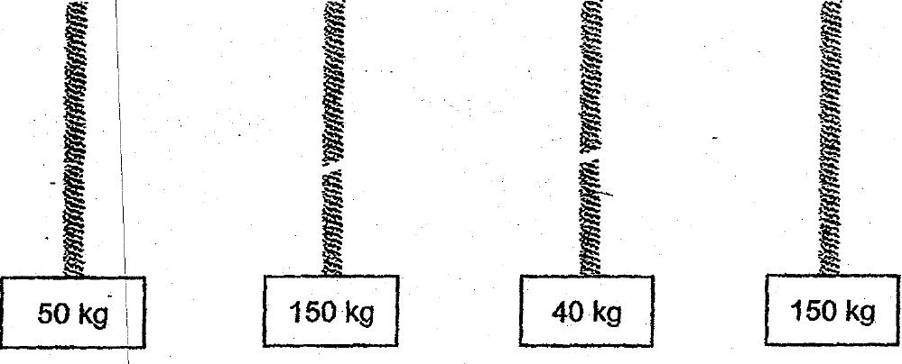

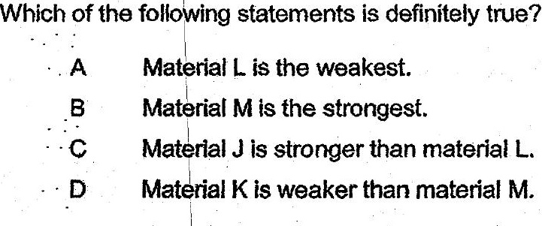

(1) Aand Bonly .  
(2) CandD only  
  
(3) A,CandD only  
  
(4) A.B, Cand\D