21. - -Astudy was conducted fo identify the factors that affect the evaporation rate  
-: of:some liquids. The table below shows the results.of the investigation.

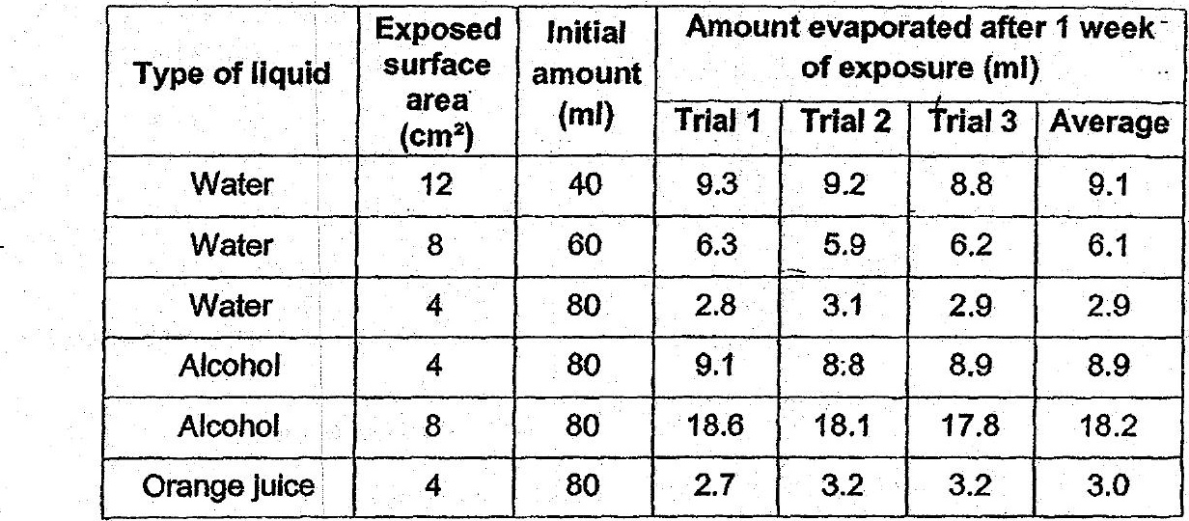

Based on the data above; which of the following statements is not correct?

(1) The evaporation rate for water is less than that for alcohol.  
  
(2) The larger the amounts of water the higher the evaporation rate.  
  
(3) . Water has approximately the same evaporation rate as orange juice.  
(4) The larger exposed surface areas of water had greater evaporation