34 Based on jines 18 to 24, state whether each statement in the table below is true or false,  
then give one reason why you think so. [3m]

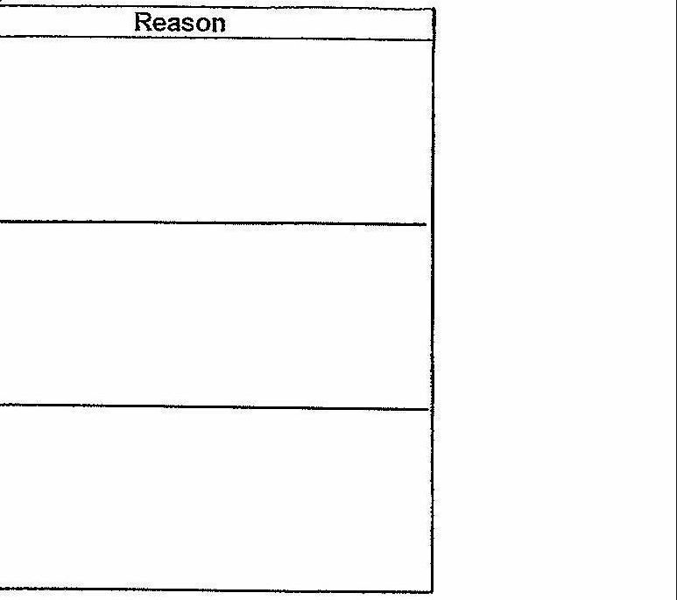





LL Ty fe fei pF rneenerefmreters-



eT LL AL A fryer repertoire