22. When John put the flask of tap water into a container of boiling water, he  
observed that the water level in the glass tube fell first before it rose.

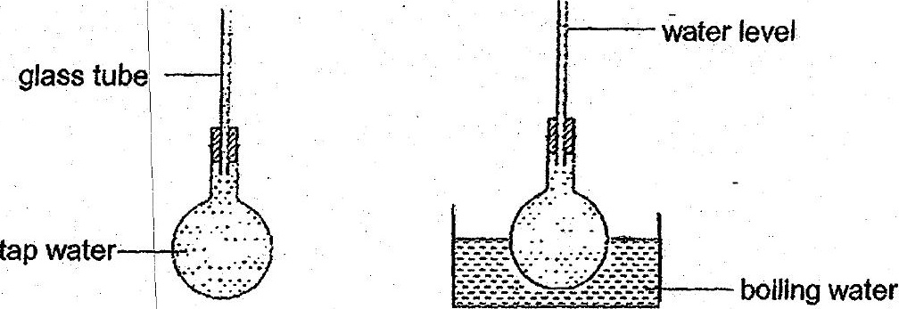

|  
Which one of the following best explains his observation?  
(1) Tap water is a good conductor of heat.  
(2) Glass is a poorer conductor of heat than tap water.  
(3) The flask expands before the water in the flask expands.  
(4) The flask contracts causing the water level in the tube to fall.