

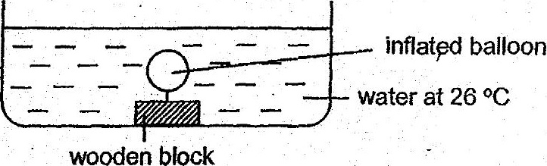

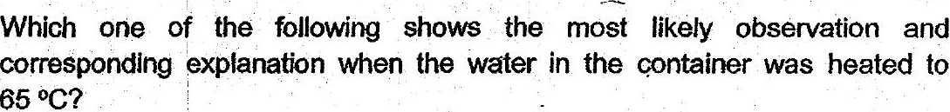

| Observation(s} . Explanation  
(4) The. balloon remained the | Heat did not cause any visible change in the |  
same size. | set-up. |  
(2) The balloon became Some air had escaped from the balloon causing  
smaller. it to reduce in size.  
(3) The balloon became bigger. | Some air from the water had entered the  
: balloon causing it to expand.  
The. balloon became bigger | Both the air in the balloon and the water in the  
(4) | and the water level in the | container gained heat and expanded.  
cohtainer increased.