CHIU ST NICHOLAS GIRLS’ SCHOOL

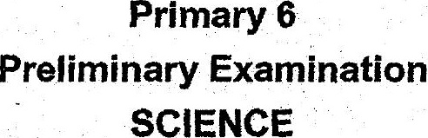



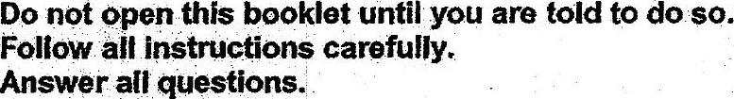

{his pooklet consists.of 27 printed pages.